HOW TO INSTALL GIT CLONE IN YOUR WINDOWS SYSTEM

Go here or see youtube video https://www.youtube.com/watch?v=albr1o7Z1nw

<https://git-scm.com/download/win>

Click GitClone Install

Go C >>Programs File>>Git>>Create Shortcut

Click cmd and git clone your files

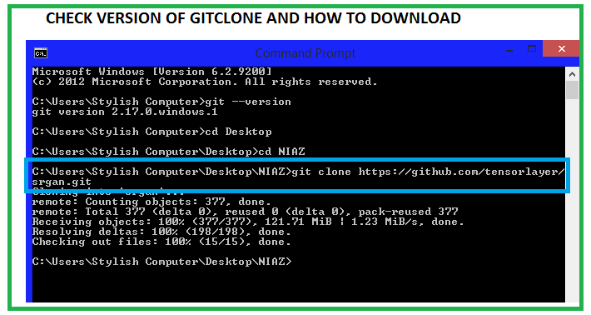

HOW TO UPLOAD NOTES ON GITHUB

My user name : check email

Password: check email

Follow below link

https://www.youtube.com/watch?v=K7g4D4sdBEQ